17TH February 2022
Supporting Service children in education

Dear Parent/Carer,

At CCYD, we are committed to understanding the needs of all learners and supporting them with their unique experiences throughout education. One such group that we aim to support is children of Armed Forces personnel.
Our school recognises that the child of a Service family may at some point in their lives need support with their learning, settling into new situations and/or mental health and wellbeing, as a result of their unique circumstances. This could be due to mobility, deployment, separation, transition, education and/or social needs.
To effectively support our Service children and strengthen Bridgend Borough Council’s commitment to the Armed Forces Covenant, we hope to identify our Service children at CCYD. By identifying the number of Service children in our school, we can be proactive in understanding their needs, making support available and accessing funding if required. We can also work with Supporting Service Children in Education Wales (SSCE Cymru) to further develop our provision for Service children.

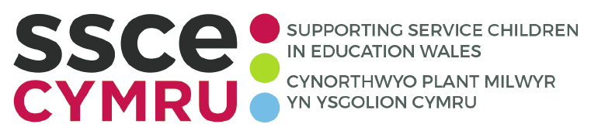

The SSCE Cymru mission is to provide the best possible educational support to Service children in Wales. SSCE Cymru works collaboratively with organisations across the UK to build an evidence base that impacts policy and systems. SSCE Cymru also provides a suite of resources to support education professionals and Service families across Wales, including Toolkits and tools, good practice examples, newsletters, funding guidance, a directory of support and films. SSCE Cymru has four Regional School Liaison Officers for Service children who can work with schools that have identified Service children, to develop knowledge, embed good practice and support access to relevant grant funding and training opportunities.
For further information, visit www.SSCECymru.co.uk

Please help us to gain an understanding of our Service community by completing the below form and returning it to the school by 18th March 2022. Annually, we share the total number of Service children enrolled at our school with SSCE Cymru. In line with GDPR guidelines, all names and identifying characteristics of children will remain confidential.

Yours Faithfully,

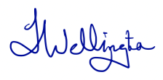

Tracey Wellington
Headteacher
Coleg Cymunedol Y Ddderwen
Parent/Carer return form

Pupil’s name ……………………………………………………………
Year group ………………

Definition 1 (Welsh Government definition)
A ‘Service child’ has parent(s) – or person(s) with exercising parental responsibility – who is/are Service personnel serving:
- in HM Regular Armed Forces
- in full commitment as part of the full-time Reserve service
- is a veteran who has been in Service within the last two years
- one of their parents died whilst serving in the Armed Forces and the pupil receives a pension under the Armed Forces Compensation Scheme or the War Pensions Scheme.
Definition 2
A person whose parent, or carer, serves in the regular armed forces, or as a reservist, or has done at any point during the first 25 years of that person’s life. *and does not meet the criteria of definition 1.

Does your child/ren fit within either of the above definitions of a Service child (please only select one option)?
☐ Yes – definition 1
☐ Yes – definition 2
☐ No

Which Service are your family connected to?
☐ Royal Navy/Royal Marines
☐ British Army
☐ Royal Air Force
☐ Veteran/ex-Service personnel
☐ N/A

To be returned to Catherine.pope@ccyd.org.uk by 18th March 2022

