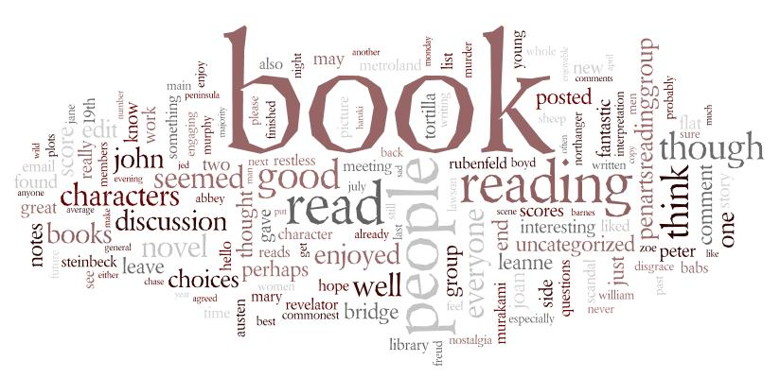
Narrative Writing Pack – Y9

Name: _______________________________

Class: _________________________________

“It's like everyone tells a story about themselves inside their own head. Always. All the time. That story makes you what you are. We build ourselves out of that story.”
― Patrick Rothfuss

“After nourishment, shelter and companionship, stories are the thing we need most in the world.”
― Philip Pullman

Lesson One
What Makes an Interesting Story?

Take another look at the quotations on the front page of the booklet. What do they tell us about telling tales? Why do you think stories are important?
Task One: What are the different elements needed to create an interesting short story? Complete the mind map below with your ideas:

What makes an interesting
short story?

Task Two: Now read the two short story on the following page. Use a marker pen to highlight features that you think make an effective short story. If you find something you haven’t yet considered, add it to your mind map

Umbrella
It was a cloudy night; the darkness covered the city like a thick blanket. The wind blew gusts of air smelling of car fumes through the streets; it sneaked under the cracks of doors and whispered down sooty chimneys.
Mr Bell hurried down a dark street, holding onto his bowler hat so that the harsh breeze couldn't steal it. The wind blew harder, almost blowing the short, stout man off-course. Eyes narrowed, Mr Bell tried again to walk into the path of the determined gale. A hazy drizzle of misty rain drifted down in sheets, making him shiver and cough. Cursing the cold, he drew his coat tighter around his large figure. As he made to clamp his hat to his head again, he spotted something black and flapping on the pavement. An umbrella!
His heart leapt; the umbrella would be perfect! Feeling pleased with himself, Mr Bell ran towards it and snatched it up. The handle was smooth and glossy, and the waterproof dome was black and very large.
As Mr Bell raised it above his head, something remarkable happened. He began to feel lighter as he ran over the cobbled street, holding tight. Lighter and lighter. With a gasp, he realised that his leather shoes were no longer making contact with the pavement. He was flying! The wind lifted him up like hundreds of hands, all pushing upwards.
With a delighted and shocked shout, Mr Bell gazed down at the sprawling city below him. The street lamps looked like beautiful, luminous flowers reaching up to him. Cars reminded him of jewel-coloured beetles crawling through the concrete maze.
The wind led him towards the park; it was the only splash of green in a grey ocean of buildings and roads. Clutching the umbrella tightly, he drifted towards two bronze statues of lions guarding the park entrance. Mr Bell outstretched his free hand and reached towards one. As he passed, he patted it on its cold head. The lion roared deeply and shook its impressive mane, whilst watching the small man float past. Wide-eyed, Mr Bell swung himself away. The umbrella swayed dangerously and as he grasped the handle harder, he waited dizzily for the world to stop spinning.
Still the wind carried him on. He glanced back at the now still statues. The trees swayed in time with the umbrella as he drifted higher again. A white barn owl flew past Mr Bell like a winged ghost.
As he rose, he scanned the sprawling city for his house. There. He gently coaxed the umbrella down towards his street. The wind rushed down and with a bump, Mr Bell landed outside his house. He looked around to check that nobody had noticed him disembarking, before making his way up the garden path. The promise of light and warmth beckoned him inside. As he stood on the front porch, he folded the umbrella up and smiled as he thought about what an exciting bedtime story his daughters would have that night.

Lesson 2 GCSE Narrative Writing Mark Scheme
Content & Organisation (14 marks)

Band One (1-4 marks) Band Two (5-7 marks) Band Three (8-10 marks) Band Four (11-14 marks)

- Controlled & coherent writing
- Narrative is organised and structured purposefully
- Range of vocabulary, occasionally used for effect
- The writing shows originality and imagination
- Material is prioritised to maintain interest
- Cohesion is reinforced by text connectives
- Ambitious vocabulary
- Basic sense of plot
- Simple chronological writing
- Limited range of vocabulary
- Basic sense of characterisation
- Appropriate beginning & conclusion
- There is a range of vocabulary

Grammar – sentences, spelling and punctuation (6 marks)

Band One (1-2 marks) Band Two (3 marks) Band Three (4 marks) Band Four (5-6 marks)
- Sophisticated used of sentences types and lengths for particular effects
- Accurate punctuation to clarify meaning
- Virtually all spellings, including complex irregular words, are correct
- Sentences are simple & compound
- Punctuation is attempted with some accuracy
- Simple words are spelt accurately
- Sentences are varied and complex sentences are used
- Some control of a range of punctuation
- Control of tense and agreement is generally secure
- Varied sentence length and range for effect
- Most spellings, including irregular words, are correct
- Control of tense and agreement is secure

Story Openings

Below are the very first sentences from various children’s novels. Look at each example of an opening sentence and think about whether or not it would interest you as a reader. Then think about what the author has done to ‘hook’ you into his/her book.
Not for the first time, an argument had broken out over breakfast at number four, Privet Drive.
‘Yes,’ said Tom bluntly, on opening the front door. ‘What d’you want?’

It was a dark, blustery afternoon in spring, and the city of London was chasing a small mining town across the dried-out bed of the North Sea.
Once, there were four children whose names were Peter, Susan, Edmund and Lucy.

It was 7 minutes after midnight.
Once I was living in an orphanage in the mountains and I almost caused a riot.

Choose an appropriate hook from the ‘good beginnings’ wheel and write the opening of a story below:
_________________________________________________________________________________________________________________________________________________________________________________________________________________

Lesson 3 - Sentence Openings

One of the most common ways to start a sentence is to begin with the thing being described as subject (first word). So we start with ‘the...’, or ‘she/he/it...’, followed by the verb (action).

For example: The lanky, unkempt fellow slinked down the canal path...

This can become boring. Instead try the following to vary your sentence openings:
- Use an ‘-ly’ (adverb) opening word: Unsteadily, the lanky, unkempt fellow slinked down the alleyway...

- Open using a word ending in ‘-ed’: Terrified, the girl darted out of the path of her pursuer...

- Start the sentence using a word ending in ‘-ing’: Ambling along the canal tow path, the intoxicated thief spied his victim...
Sentence Lengths
Read the following extract:
The attic door creaked open. Something rustled in the darkness. I stared, but could see nothing beyond the vague shapes of old suitcases and trunks piled high. It smelt damp. I struggled up into the attic and wedged the door open. Light poured into darkness. The darkness in the head of the house. I balanced carefully upon the floor beams. I knew that if I stepped onto plaster I could fall straight through into the room below. A cobweb brushed my face and I felt the sudden tickle of a spider crawl across my cheek. As I made my way forwards, it grew darker and colder. I was blocking the light from the attic door. There were piles of old newspapers, brown bags tied with string cardboard boxes and ancient, moth eaten rugs that smelt of mothballs. Thick dust powdered every surface. I kept thinking that I could slip and put my foot through the floor. I stopped at a pile of old camping equipment. It was a jumble of guy ropes, torn canvas, poles, wooden pegs, metal skewers and a mallet. It was there that I saw the hand. It was quite still and white, like a marble. But then it moved.

- What do you notice about the sentence lengths? Why are they important?

- What atmosphere is created in the passage? How does the writer build tension?

- What other techniques does the writer use to create the atmosphere?

Lesson 4 and 5 - Practice Titles
Now it’s time to use the skills you have learnt so far. Choose a title from one of the five below:
- The Hidden Book

- The Accident
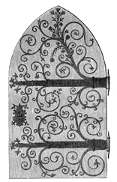
- The Broken Mirror

- The Secret Door

- The Unexpected Guest

Elements to consider when planning your story:

- First person or third person narrative?
- Choose one or two main characters
- Choose one setting
- Consider how much time can take place in the story?
- Consider the time sequence? Does your story take place in chronological order?
- Your story MUST be closely related to your title
- Your story MUST be original and interesting

Task: Plan your story below in a mind map. Resolve the ideas above in your plan.

Complete a draft of your story below.

Title:

__________________________________________________________________________________________________________________________________________________________________________________________________________________________________________________________________________________________________________________________________________________________________________________________________________________________________________________________________________________________________________________________________________________________________________________________________________________________________________________________________________________________________________________________________________________________________________________________________
____________________________________________________________________________________________________________________________________________________________________________________________________________________________________________________________________________________________________________________________________________________________________________________________________________________________________
____________________________________________________________________________________________________________________________________________________________________________________________________________________________________________________________________________________________________________________________________________________________________________________________________________________________________
____________________________________________________________________________________________________________________________________________________________________________________________________________________________________________________________________________________________________________________________________________________________________________________________________________________________________
____________________________________________________________________________________________________________________________________________________________________________________________________________________________________________________________________________________________________________________________________________________________________________________________________________________________________
____________________________________________________________________________________________________________________________________________________________________________________________________________________________________________________________________________________________________________________________________________________________________________________________________________________________________
____________________________________________________________________________________________________________________________________________________________________________________________________________________________________________________________________________________________________________________________________________________________________________________________________________________________________
____________________________________________________________________________________________________________________________________________________________________________________________________________________________________________________________________________________________________________________________________________________________________________________________________________________________________
____________________________________________________________________________________________________________________________________________________________________________________________________________________________________________________________________________________________________________________________________________________________________________________________________________________________________
____________________________________________________________________________________________________________________________________________________________________________________________________________________________________________________________________________________________________________________________________________________________________________________________________________________________________
______________________________________________________________________________________________________________________________________________________________________________________________________________________________________________________________________________________________________________________________________________________________________________________________________________________________________________________________________________________________________________________________________________________________________________________________________________________________________________________________________________________________________________________________________________________________________________________________________________________________________________________________________________________________________________________________________________
Look over your draft and check you have used paragraphs and punctuation correctly.
Lesson 6 - Paragraphs & Punctuation

How low can you go?
Did you know that punctuation has levels?

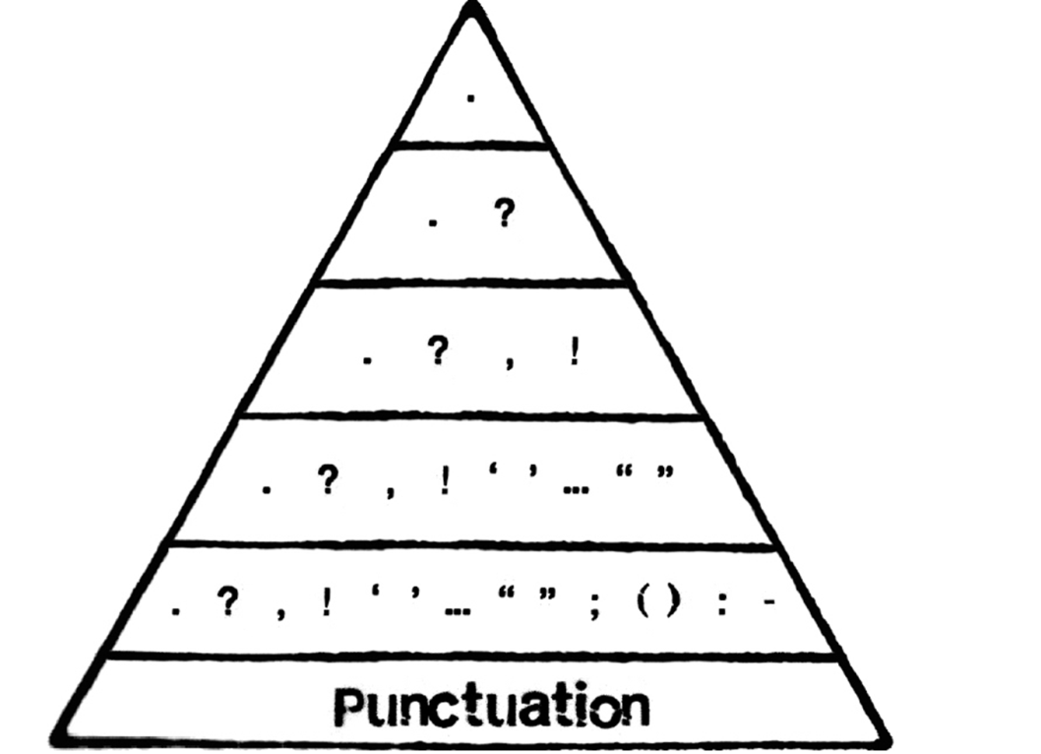

Characterisation

One way of making your writing more interesting is to SHOW rather than TELL.
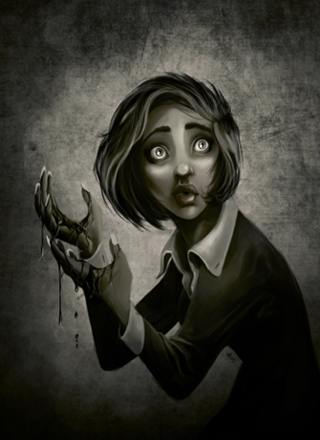
For example:
Telling:
She was frightened.
Showing:
Goosebumps travelled up her fair skin and her mouth went horribly dry. Her hands began to shake uncontrollably but her feet became lead weights that refused to move.

Remember to use:
- Interesting verbs - 'doing' words or 'being' words. E.g. 'walk', ‘feel’
- Adverbs – words that add information to the verb.
- Adjectives - describing words that tell you more about nouns.

Task
Create a character using the ‘show, don’t tell’ rule. He or she should express an emotion.
_____________________________________________________________________________________________________________________________________________________________________________________________________________________________________________________________________________________________________________________________________________________________________________________________________________________________________________________________________________________________________________________________________________________________________________________________________________________________________________________________________________________________________________________________________________________________________________________________________________________________________________________________________________
Varied Vocabulary – Synonyms

Task One: Using a thesaurus, create a vocabulary list for the following words. The first one has been done for you.

- Slim: thin, trim, slender, lean, wiry.

- Cold:

- Hot:

- Happy:

- Sad:

Task Two: Use the new words from your vocabulary list in a sentence. The first one has been done for you.

- Slim: The teenage girl was very slender.

- Cold:

- Hot:

- Happy:

- Sad:

Task Three: Make these sentences more interesting by using similes, metaphors, personification, adjectives and adverbs. The first one has been done for you.

- I was very sad.

Tears of sorrow streaked my face.

- He was proud.

- The wind was strong.

- I was excited.

- It was a hot evening.

Lesson 7 and 8 - Narrative Titles
Choose one of the following titles to create your narrative:
- The Cheat
- The Coming Storm
- The Betrayal
- Coming Home
- The Gift

- Write about a time when you lost something of importance
- Write about a time when you were forced into doing something that you really didn’t want to do
- Write about a time when something you had carefully planned did not work out as expected
Plan
Use the mind map below to come up with as many ideas as possible based around your title:
Writing Descriptively: Planning Sheet
Five Senses

Sight | Smell | Sound | Taste | Touch
Interesting Vocabulary and Difficult Spellings
Imagery (similes/metaphors/personification)

Descriptive Words (adjectives/adverbs)
Structure of a Short Story
First Sentence: direct speech, exclamation, question …

Beginning (Exposition):
What do you need to tell your reader about the characters, setting and plot to keep them engaged?

Middle (Problem):
What do you need to add to keep your reader interested? How can you build suspense/tension?

Climax:
What is the event that occurs before the problem is solved and the readers’ questions are answered?

Ending (Resolution):
How will you end so that the problem is resolved and satisfy the reader? Will you create an unexpected ending?

You can visualise the story structure as a graph:
Resolution
Climax
Problem

Exposition
Complete a draft of your story below.

Title:

__________________________________________________________________________________________________________________________________________________________________________________________________________________________________________________________________________________________________________________________________________________________________________________________________________________________________________________________________________________________________________________________________________________________________________________________________________________________________________________________________________________________________________________________________________________________________________________________________
____________________________________________________________________________________________________________________________________________________________________________________________________________________________________________________________________________________________________________________________________________________________________________________________________________________________________
____________________________________________________________________________________________________________________________________________________________________________________________________________________________________________________________________________________________________________________________________________________________________________________________________________________________________
____________________________________________________________________________________________________________________________________________________________________________________________________________________________________________________________________________________________________________________________________________________________________________________________________________________________________
____________________________________________________________________________________________________________________________________________________________________________________________________________________________________________________________________________________________________________________________________________________________________________________________________________________________________
____________________________________________________________________________________________________________________________________________________________________________________________________________________________________________________________________________________________________________________________________________________________________________________________________________________________________
____________________________________________________________________________________________________________________________________________________________________________________________________________________________________________________________________________________________________________________________________________________________________________________________________________________________________
____________________________________________________________________________________________________________________________________________________________________________________________________________________________________________________________________________________________________________________________________________________________________________________________________________________________________
____________________________________________________________________________________________________________________________________________________________________________________________________________________________________________________________________________________________________________________________________________________________________________________________________________________________________
____________________________________________________________________________________________________________________________________________________________________________________________________________________________________________________________________________________________________________________________________________________________________________________________________________________________________
__________________________________________________________________________________________________________________________________________________________________________________________________________________________________________________________________________________________________________________________________________________________________________________________________________________________________________________________________________________________________________________________________________________________________________________________________________________________________________________________________________________________________________________________________________________________________________________________________

